Beneficiary card – Hotel International Iasi

Activity profile:

* Housing
* Parking stations (normal and subterranean spaces)
* Restaurants:   
  TIROL RESTAURANT - located on the ground floor  
  AL FRESCO - located on the ground floor  
  SOFIA SKY LOUNGE - perched on the 11th
* Spa & Fitness

Sauna

Massage  
Steam bath  
Fitness studio

Number of employees:

* 2 Gatekeepers
* 4 Receptionists
* 2 Hostess
* 8 Housekeepers
* Event manager
* 3 Head Chef
* 6 Junior Chef
* 6 Barkeeper
* 3 Dish Washers
* Night audit
* General Manager
* CEO
* 15 Waitresses
* Technical Crew: 2 technicians

The organizational structure

CEO

Front-office Kitchen Restaurant

Floor

Receptionist Chef & Junior Chef Barkeepers

Housekeepers

Dish Washers Waitress

Buildings Layout

Room layout

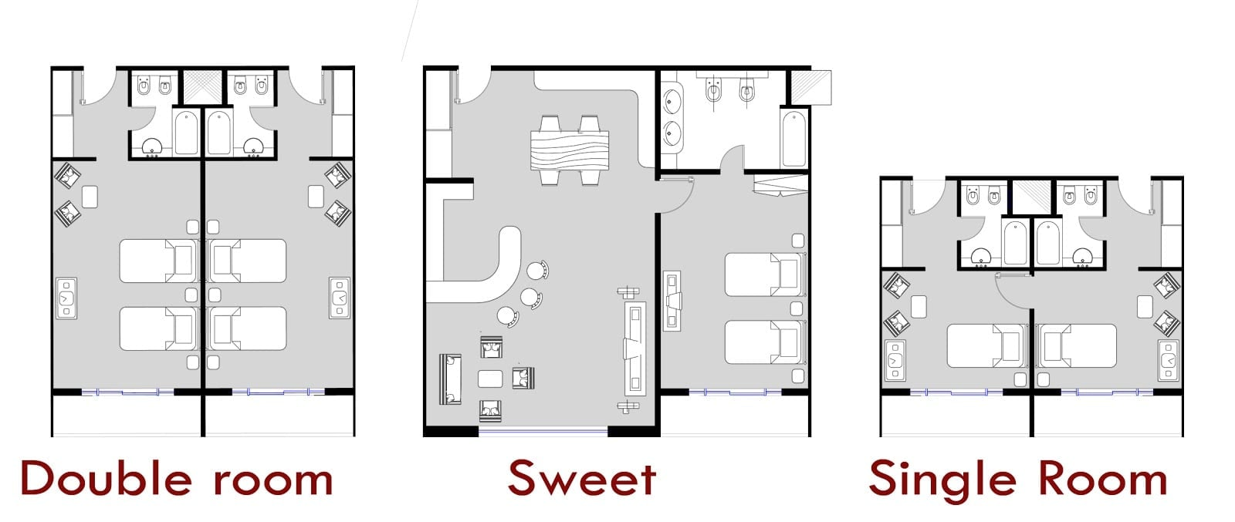

Building Layout

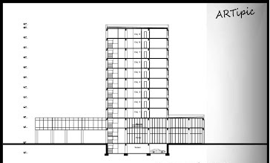

Development plans

The development plan for the future years is to extend into new areas in order to facilitate people which are visiting our country in order to have a broader view of the area.

We plan to create our own touristic guideline in order for the tourists to come and have a full experience. The goal is to open our own tourism center which will include road trips, bus rides and a personal group guide for each group of tourist which are accommodated in our hotel. In order to achieve this goal we will have to make the following purchases:

1. 2 Buses of 24+1 seats
2. A new location for the tourism center
3. Furniture and accessories
4. Equipment and miscellaneous

We will have the following posts available:

* + 2 Tourism agents
  + 2 Bus drivers
  + 1 Receptionist
  + 2 Guides
  + 1 Event organizer
  + 1 Manager

Students:

* Maftei Ilie Madalin
* Buliga Ionut